**Cost effective honey warmer for small beekeeper operations**

Like most suburban beekeepers, the size of my operation means I have to think carefully about the sort of equipment I need and can afford. My 20 or so hives brings in a good harvest of honey which I sell throughout the year. But, as we all know, most honey sugars when kept for a while and needs gentle warming to help it flow well and look acceptable to customers.

However, an electric honey warmer sold by beekeeping suppliers is an expense I cannot justify. So, with a bit of glue, tape, insulation board, two ex-political corflute signs (thank you for the donation) and a throw-size electric blanket, I made my own.

I wanted something that would warm honey stored in 20 litre containers in a way that gave me control of the temperature and heating time. Here is how I made.

1. Some left-over 50mm Knauf Insulation board from another project was enough for the four sides of a box large enough to hold a 20 litre container and a bit more. A quick fossick through a nearby builder’s bin gave me two insulation boards the right size for the floor and lid for the box. These also improved the insulation ability of the structure.
2. A squirt of builders’ glue and some tape held the structure together and I had the honey warmer box made. To improve the insulation and give the structure a bit of protection, I cut two corflute signs to size and glued and taped them around the box.

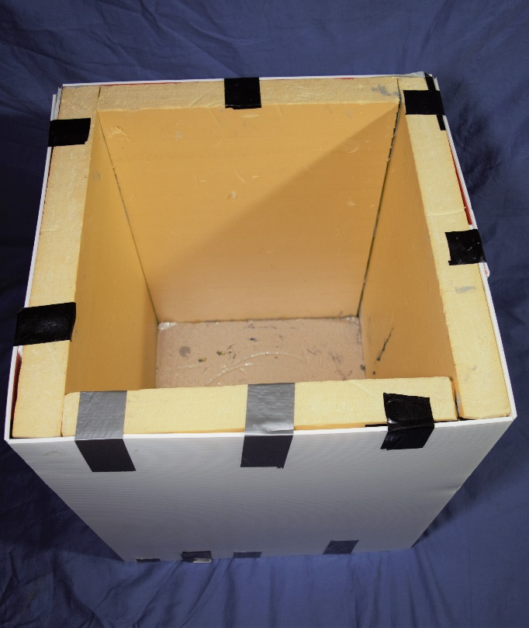

Completed warming box

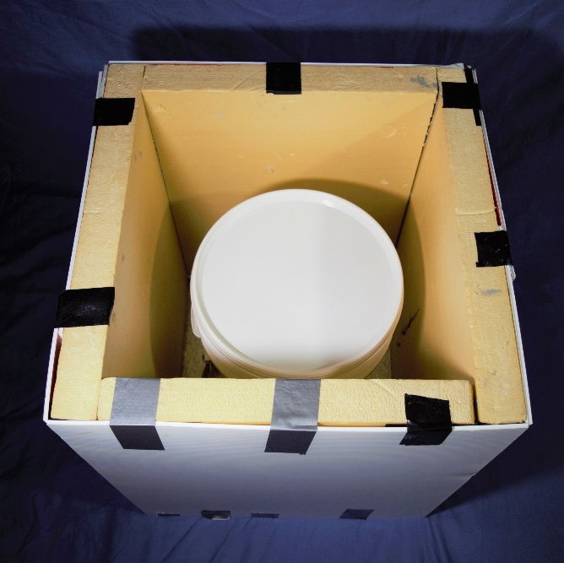

Warming box with 20 litre container

1. For the heating. I spied just what I needed in an Aldi catalogue – a cheap electric throw blanket with a thermostat and timer.

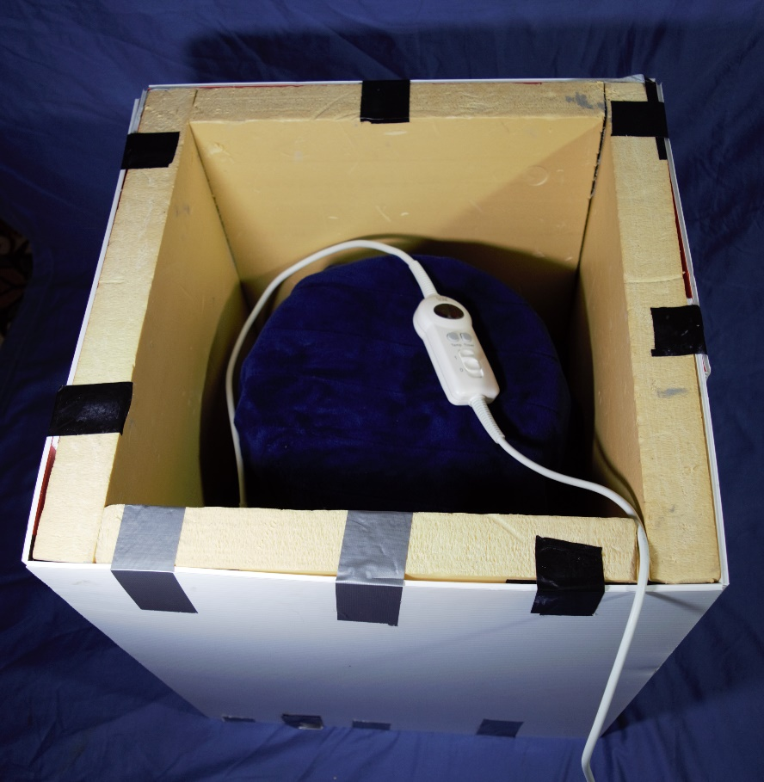

Warming box with throw blanket covering 20 litre container

Warming the honey

When I need to heat honey up, I place a container in the box, wrap the blanket around the container, set the timer and temperature, put on the box’s lid, wait and, hey presto, warm honey.

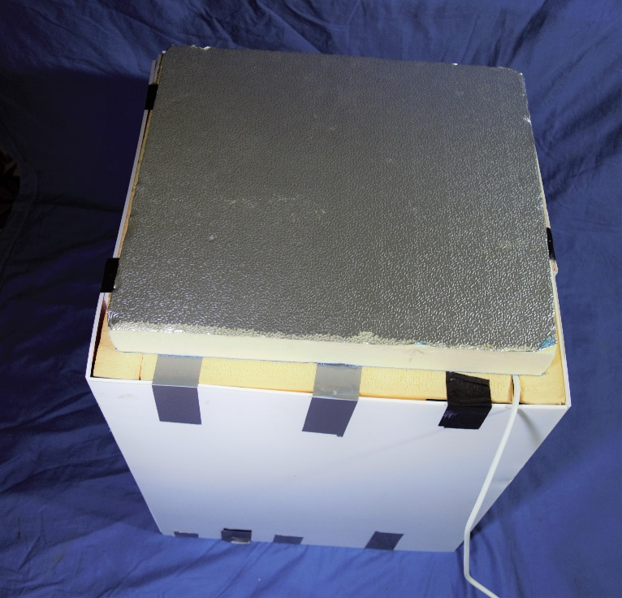

Warming box with lid.

It works like a dream, and the only outlay was $20 for the electric blanket.

The one improvement I plan to make is to scrounge a bigger sheet of builder’s insulation for a better fitting lid.

Tony Wilsmore

Suburban Bees